Proposed Geoengineering Schemes

From Wikipedia, the free encyclopedia

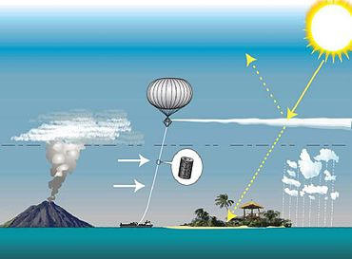

One of many proposed geoengineering schemes is the concept of managing solar radiation using a tethered balloon to inject sulfate aerosols into the stratosphere.

This is a **list of notable geoengineering schemes** proposed in scientific journals. This article is about climate engineering geoengineering.

Solar radiation management, cloud modification

Solar radiation management

**Atmospheric projects**

General proposals

* Reflective aerosols or (atmospheric) dust
* Reflective engineered nanoparticles
* Stratospheric sulfur aerosols
* Marine cloud brightening
* Ocean sulfur cycle enhancement
* Ocean mixing
* Reflective balloons
* Modified ship /aircraft exhaust composition
* Stratospheric Particle Injection for Climate Engineering

**Terrestrial albedo modification**

* Cool roof
* Reflective plastic sheetingcovering desert and glaciers
* Building thicker sea ice

**Land management and bio-geoengineering**

*Further information: Bio-geoengineering*

* Tropical reforestation
* Grassland modification
* High-albedo crops.

Ocean schemes

* Oceanic foams
* Ocean hydrosols
* Bering Sea dam
* Barriers to seawater exchange in front of shelf ice

Space projects

* Space sunshade
* Mining moon dust or asteroids.
* Diffraction grating or lens in space, (L1 point)
* Lunar spectrum shifting – to accelerate chlorophyll metabolic clocks

Greenhouse gas remediation

*Main article: Greenhouse gas remediation*

*See also: Climate change mitigation*

**Carbon sequestration**

*Main article: Carbon sequestration*

**Biological processes**

* Ocean iron fertilization
* Ocean urea fertilisation
* Reforestation
* Peat production
* Ocean mixing
  + HadCM3, a coupled atmosphere-ocean general circulation model

**Physical processes**

* Biochar burial
* Bio-energy with carbon storage
* Burying biomass
* Biomass ocean storage
* Carbon capture and storage

**Chemical techniques**

* Mineral carbonation / mineral sequestration.
* Carbon negative cement
* Oil shale ash
* Carbon air capture
* Ocean acid neutralisation
* Ocean hydrochloric acid removal

**Other greenhouse gas remediation**

* CFC laser photochemistry

Other schemes

* Ocean heat transport
* Methane remediation

This page was last modified on 22 March 2017, at 21:09.